GB DRY FRUITS

(Project Proposal)

Project Code
SEP383946

Project Advisor
Ms. Samreen Razzaq

Project Manager
Dr. Muhammad Ilyas

Project Team
Muhammad Sajid Bsef18m039 (Team leader)
Muhammad Saqlain Bsef18m038 (Team member)
Rafiuddin Bsef19m046 (Team member)

Submission Date
Tuesday, October 11, 2022

_______________
Sign of supervisor

Table of Contents
1. Abstract 3
2. Background and Justification 4
3. Project Methodology 4
4. Project Scope 5
5. High-level Project Plan 5
6. References 6

Abstract
Our country has been gifted with natural tasty and healthy fruits. Among them, the dry fruits of GB have their own taste and important. There is a high demand for the dry fruits in all over the country but the physical merchants cannot fulfill the requirements of every single person, although there are price issues. Even though some of the areas of the country do not have the approach to get dry fruits, there is no scheme in the Semi-provincial (GB) for home deliveries. people are not aware of the health benefits. People from the areas like Gilgit are facing difficulties to get the advantages from their own properties of dry fruits due to low sales and fewer buyers. Our project's main goal is to provide an easy way to sell and purchase the product. We can meet the demand by rating the requests for purchasing. Through our website, we will be available 24 hours for the customer which cannot be possible for a physical shop, and the prices will be fixed with time. We will provide the facility of home delivery and return policies. We will be available for those who do not have any approach to dry fruits physically. People from the main areas from which we are making our business can get enough advantage and agreements from our website for providing us the products.

Background and Justification
In the Pakistani region of Gilgit Baltistan, dry fruits and medicinal plants are important sources of income for the native population. Plant life has always been essential to human existence in some way. The interaction between people and their planet, especially its plants, has changed significantly during the previous several decades (Khan et al., 2015a). Before this, most people still resided in rural areas and subsisted on local plants. As natural ecosystems and indigenous cultures are being destroyed in recent years by the advance of development, a significant quantity of indigenous knowledge is being lost quickly (Khan et al., 2015b). The residents' main sources of income are dry fruit and almonds (Badam). Common dry nut Prunusamagdalus has significant medicinal value (Awan et al., 2013).
There are multiple websites for dry fruits that are already providing these features such as custom domain, Selling and purchasing, add to cart, update cart, billing detail, and products, shopping cart with checkout, secured payment, WhatsApp chat integrations, integrated social media.
But the problem is that many websites are not showing search products, Regional language support, Map directions, Enquiry forms, Feedback, Preservation technique, Health benefits, aware people about unique products, Home delivery and return policies, ads and campaign policies, Exhibition and Market news.

Project Methodology
The best methodology for our project development is the agile methodology to make it easy to accommodate the changes made during the development. We proposed a better solution to sell and purchase dry fruits products, customer satisfaction, predictability, continuous improvement, productivity, quality, fast delivery, search products, and preservation technique.
The first step that we will follow to achieve our objectives are to check out the need for dry fruits in the market, identify places that have internet facility and lack availability of dry fruits, aware the people for the need of dry fruits according to health and medical point of view. Then we will proceed to the next step, which will be consultation with GB individuals who sell the fruits at wholesale prices, after which we will begin our development process.

Project Scope
The functionalities that our website will provide are Selling and purchasing, add to cart, update cart, billing detail, shopping cart with express checkout, secured payment, WhatsApp chat integrations, regional language support, map with directions, integrated social media, enquiry form, Home delivery, online payment, cash on delivery, discount offers. We will set our ad campaigns for the target audience. To dictate the audience by age, gender, income, location, interests, or through other factors we will acquire different policies.

High-level Project Plan
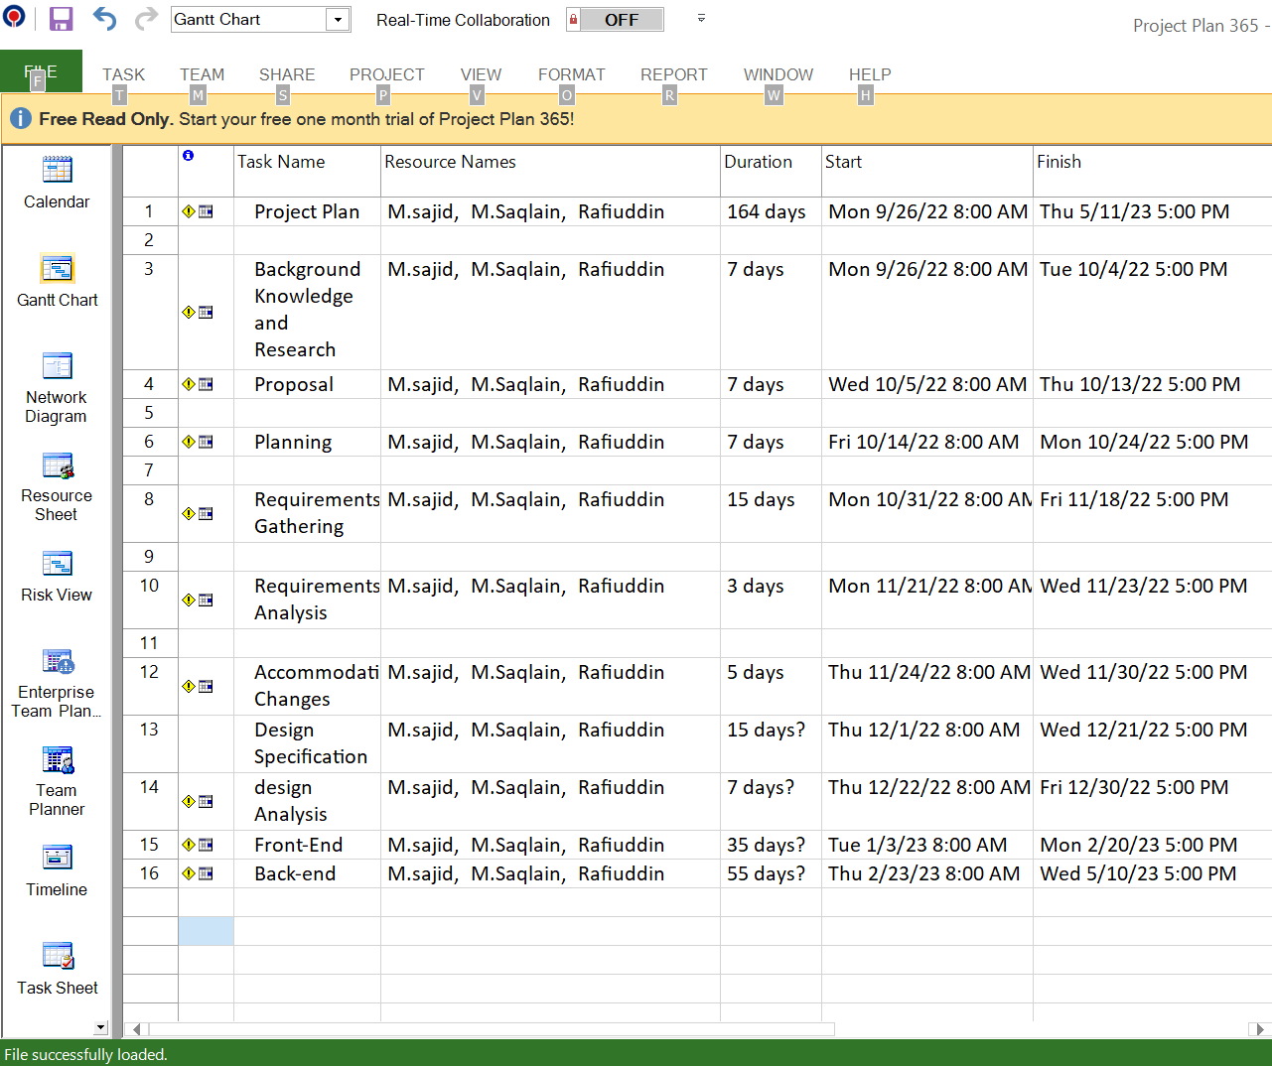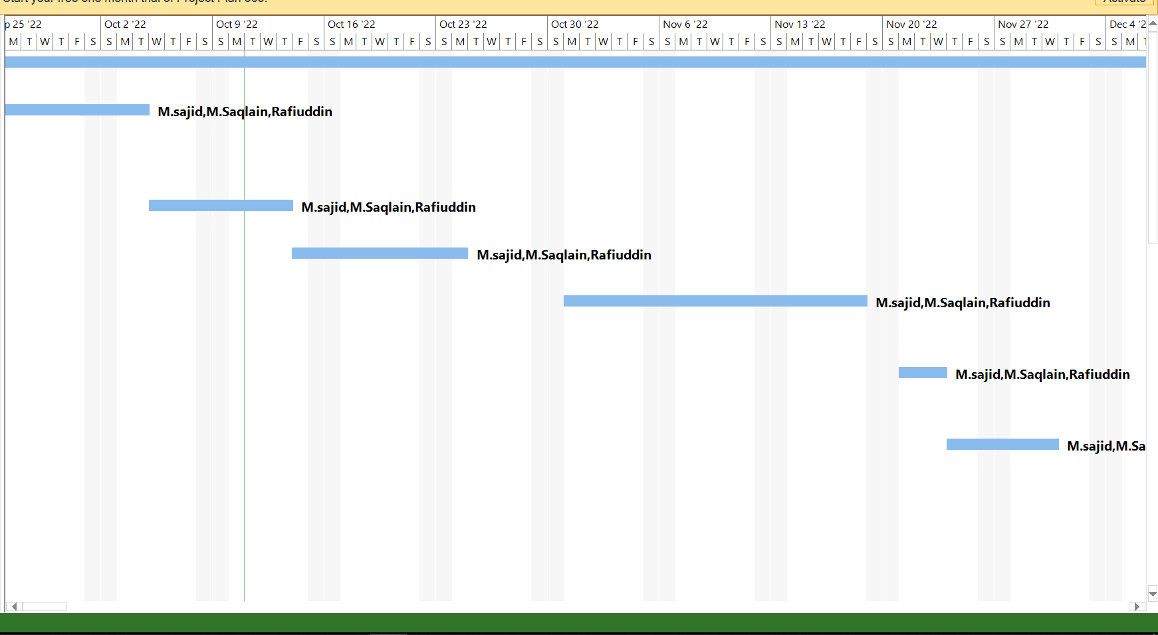

References
Ali, S., Ali, A., Sartaj, A., Ali, M., & Amjad, A. (2020). Natural occurrence of aflatoxin B1 In dry fruits of Gilgit-Baltistan, Pakistan. Fresenius Environ. Bull, 29, 2818–2822.
Awan, M. R., Jamal, Z., & Khan, A. (2013). Ethno-botanical studies of economically important plants from mountainous region of Gilgit-Baltistan, Pakistan. Sci Tech Dev, 32(4), 308–318.
Khan, S. W., Abbas, Q., Hassan, S. N., Khan, H., & Hussain, A. (2015a). Medicinal Plants of Turmic Valley (Central Karakoram National Park), Gilgit-Baltistan, Pakistan. Journal of Bioresource Management, 2(2), 11.
Khan, S. W., Abbas, Q., Hassan, S. N., Khan, H., & Hussain, A. (2015b). Medicinal Plants of Turmic Valley (Central Karakoram National Park), Gilgit-Baltistan, Pakistan. Journal of Bioresource Management, 2(2), 11.

